- AWS EC2 Instance Setup
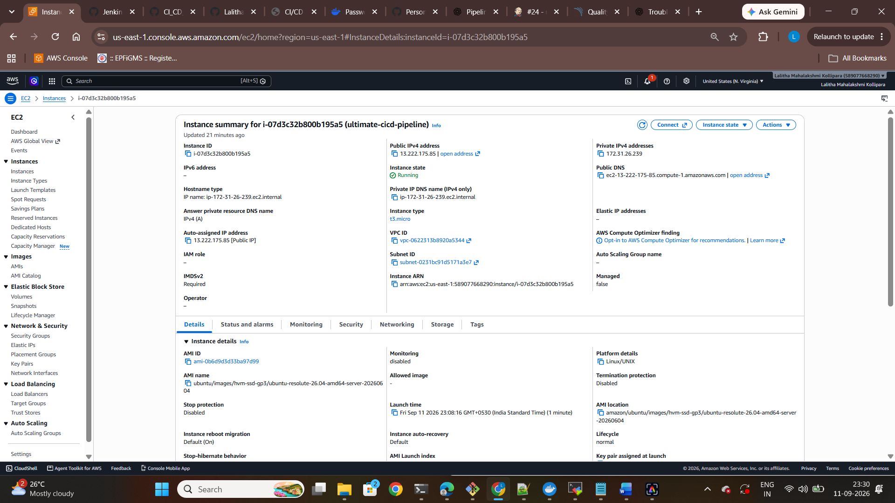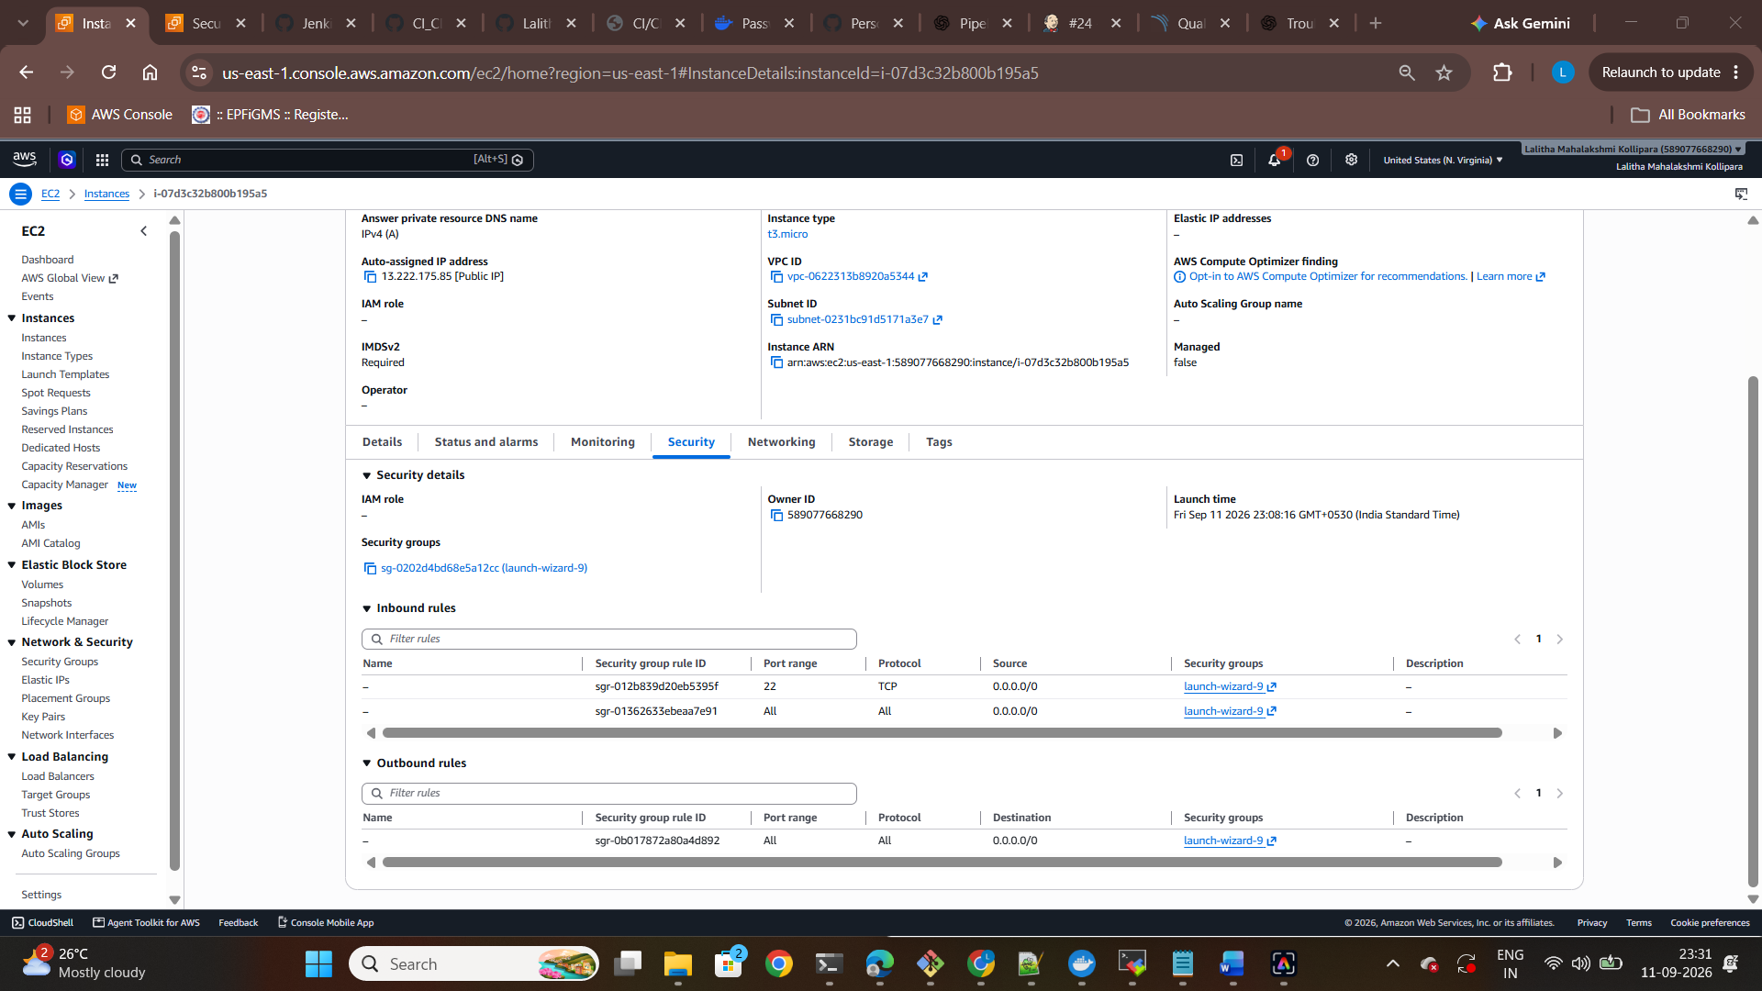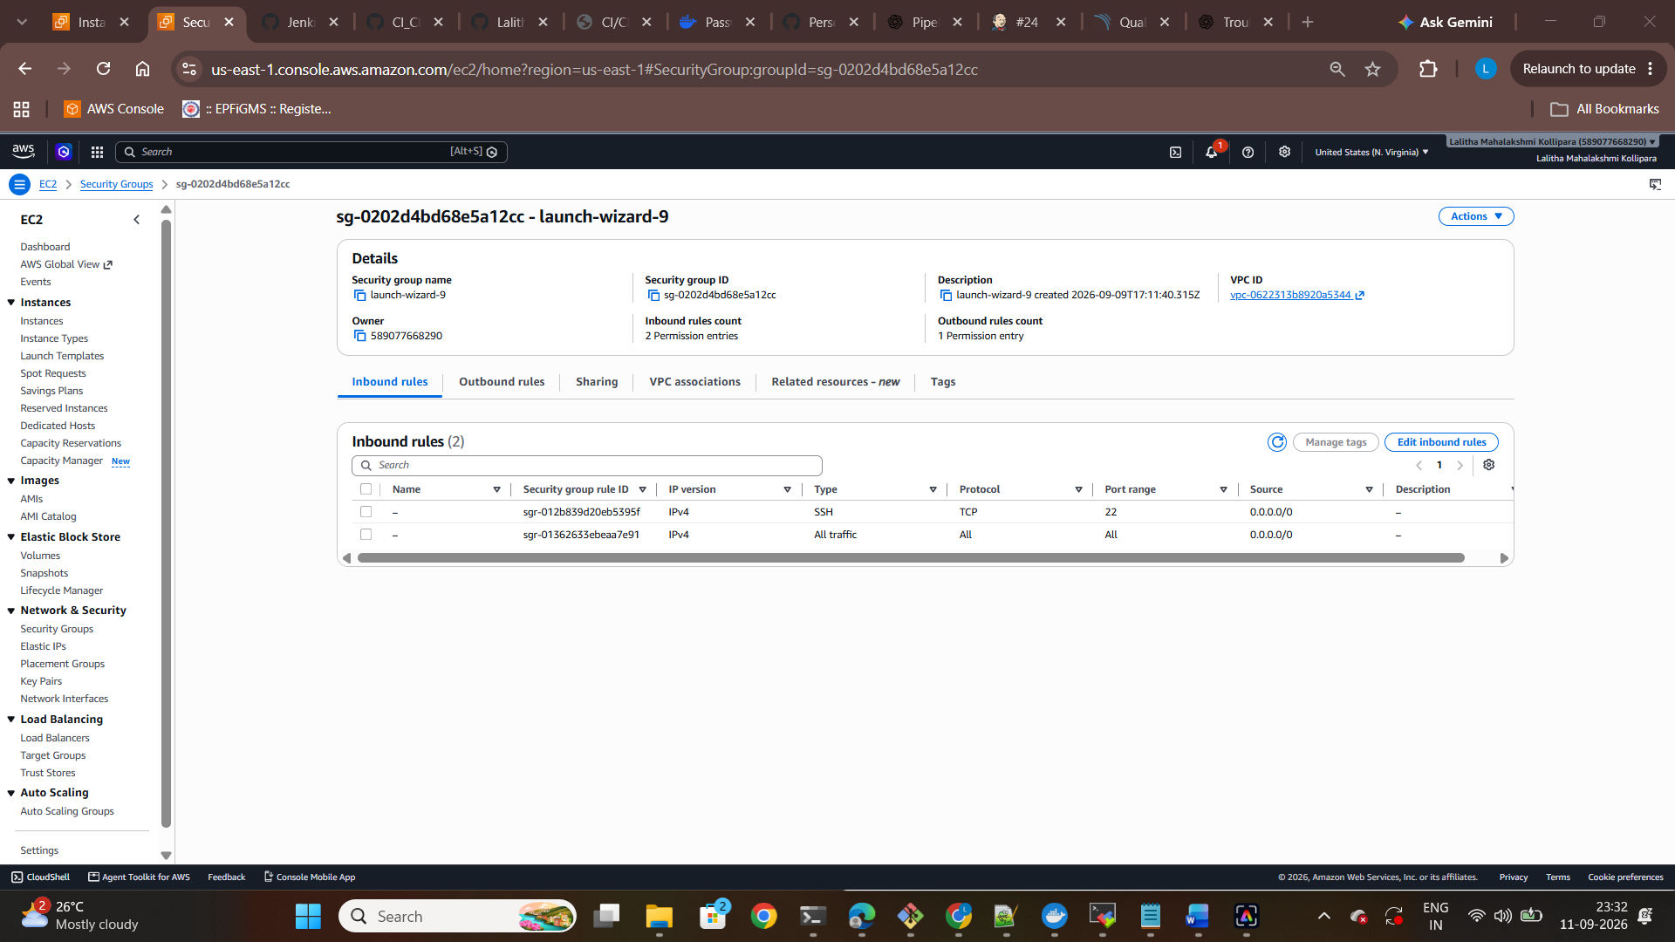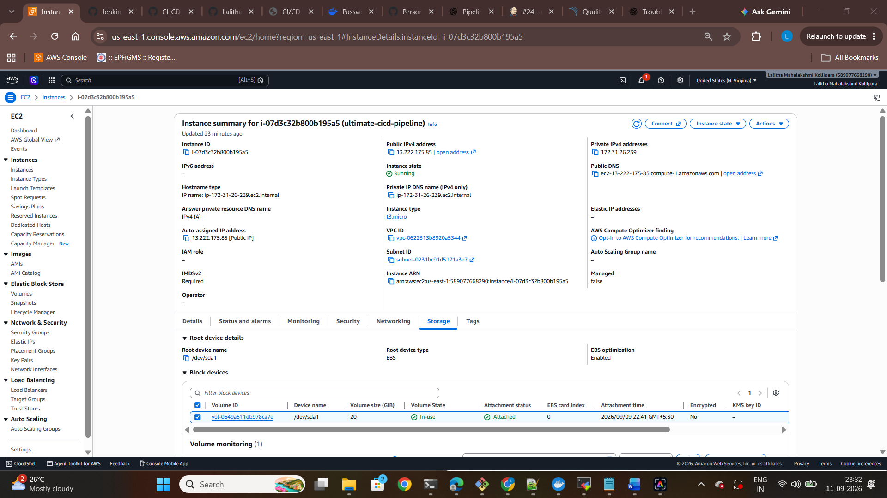
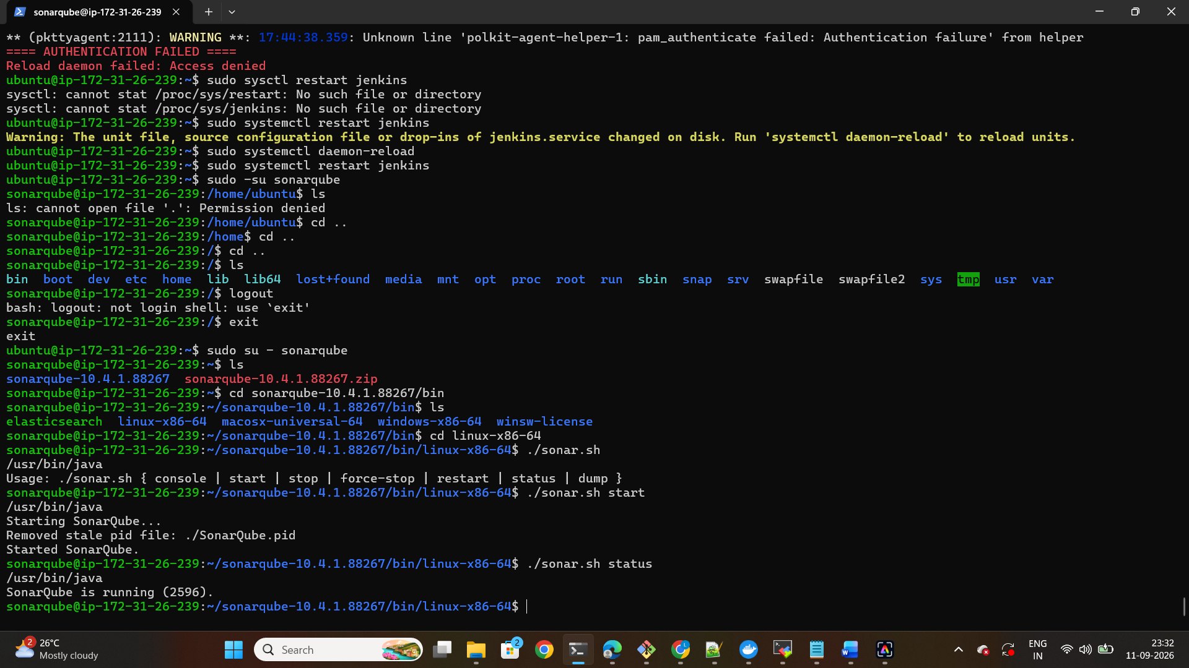
- EC2 Memory, Swap and Disk Configuration
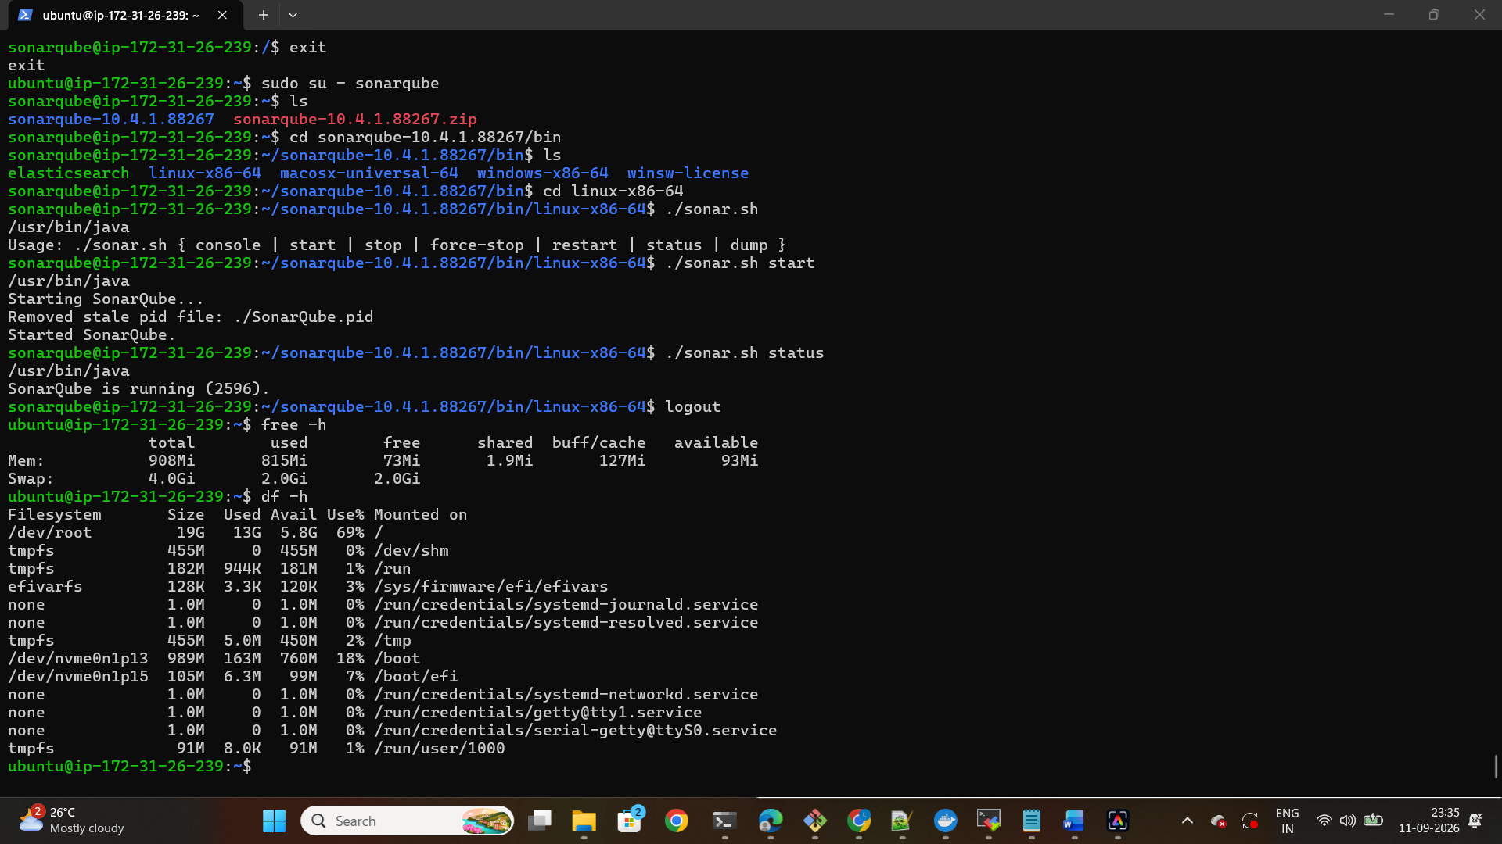

- Jenkins Service Run:
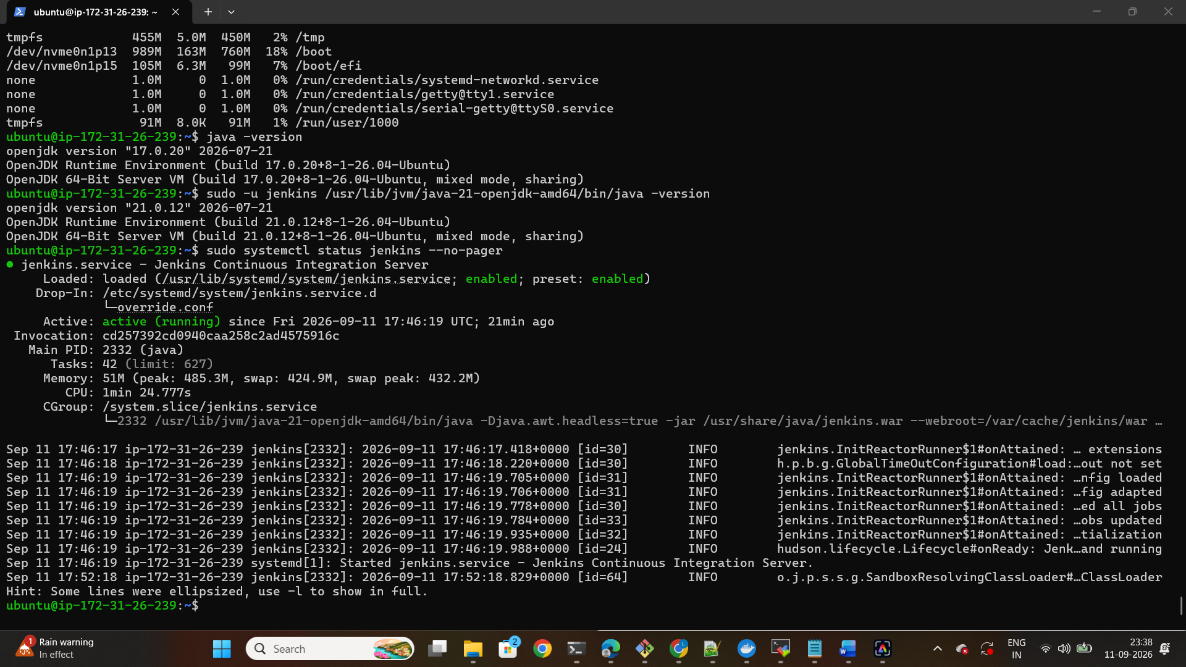

Component | Java
Sonarqube | Java 17
Jenkins | Java 21

- Sonarqube Server Running
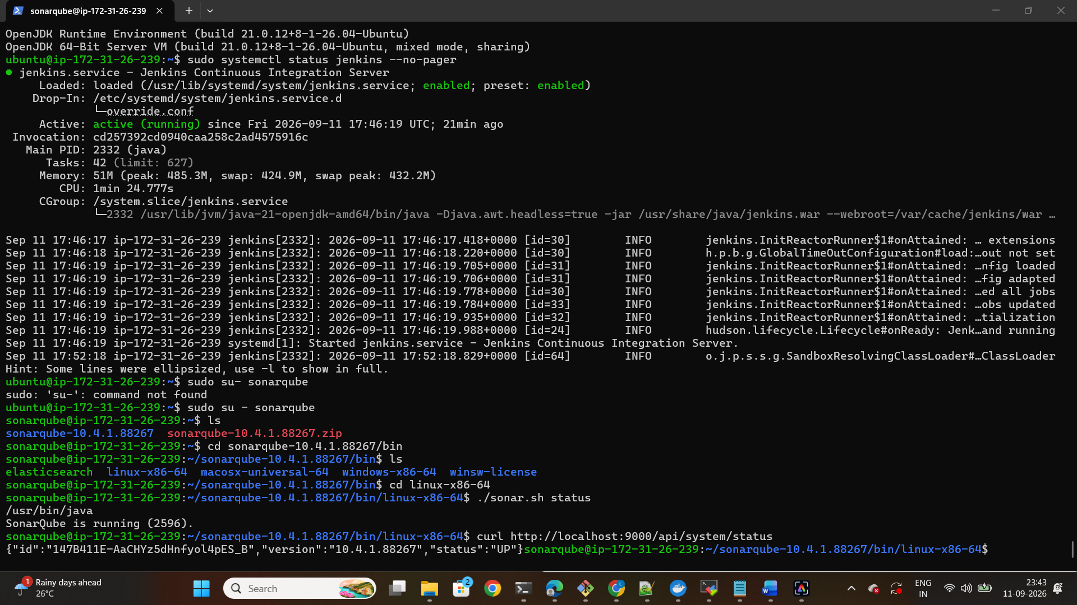

- Sonarqube Dashboard:
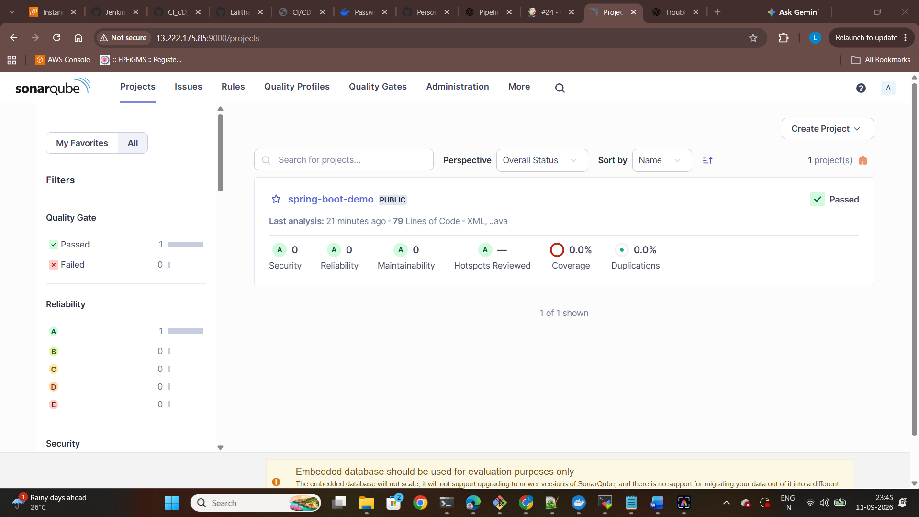
- Docker Installation and Images
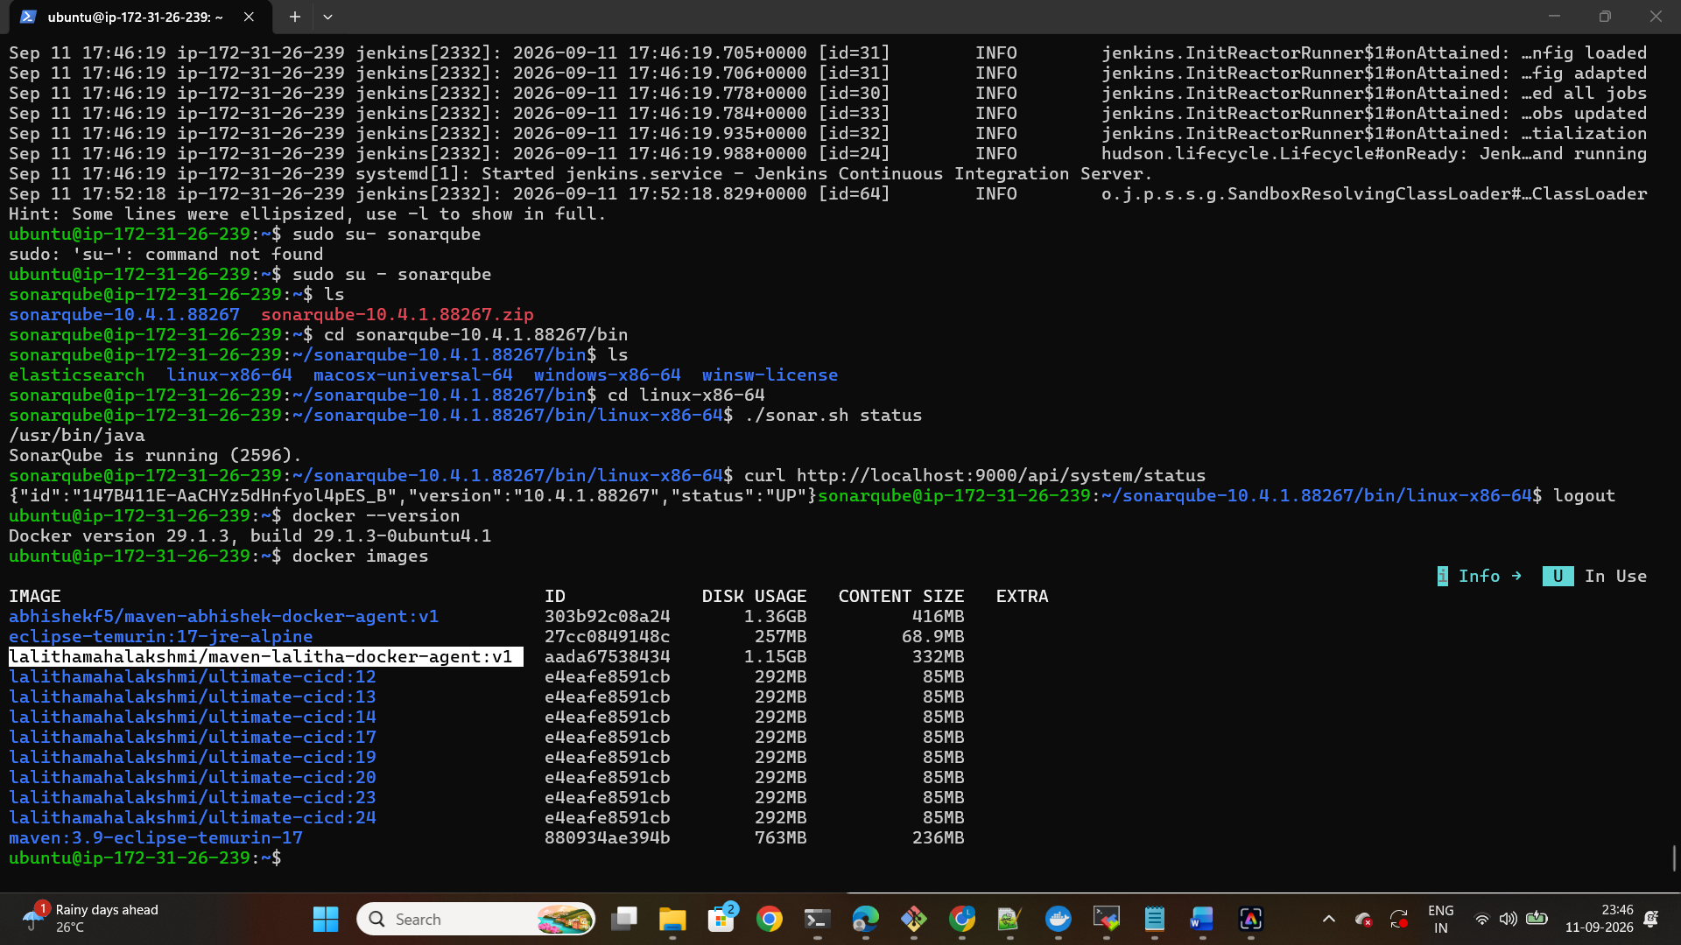

- Docker Image pushed to Docker hub:
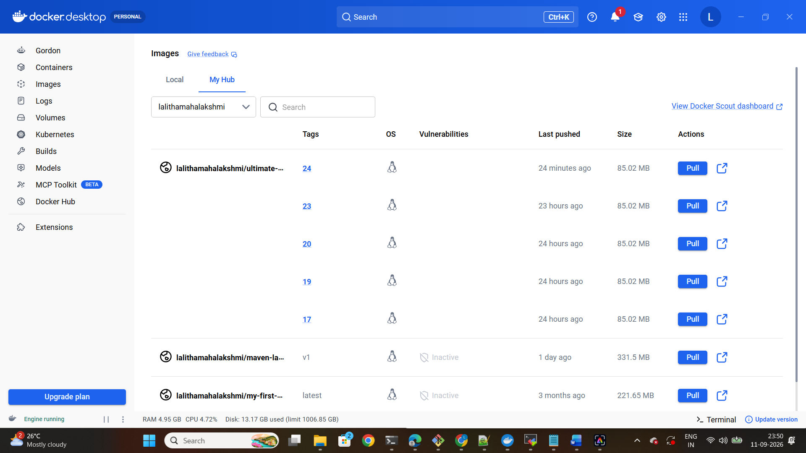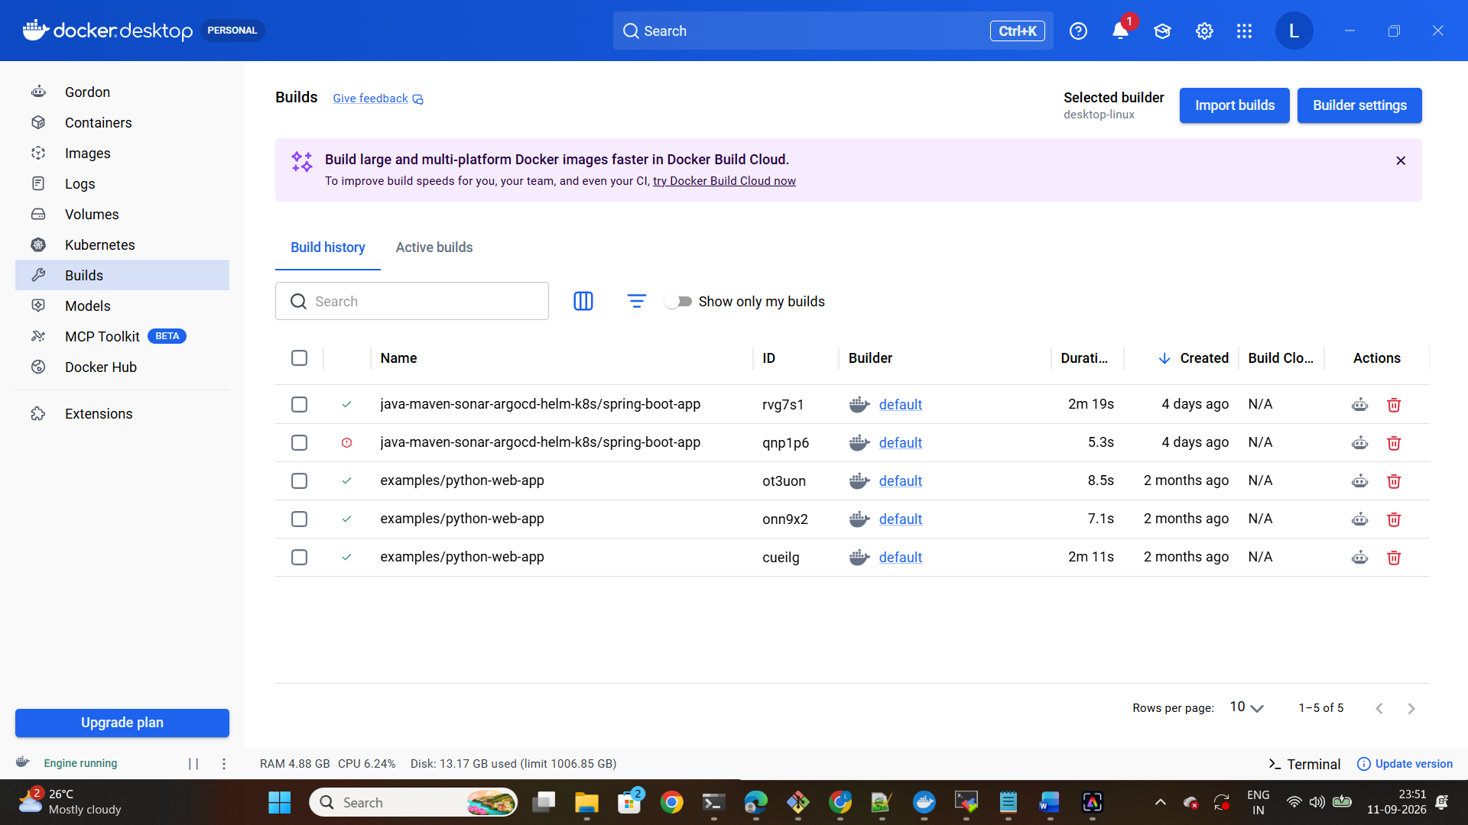

- GitHub Repository and Jenkins File:
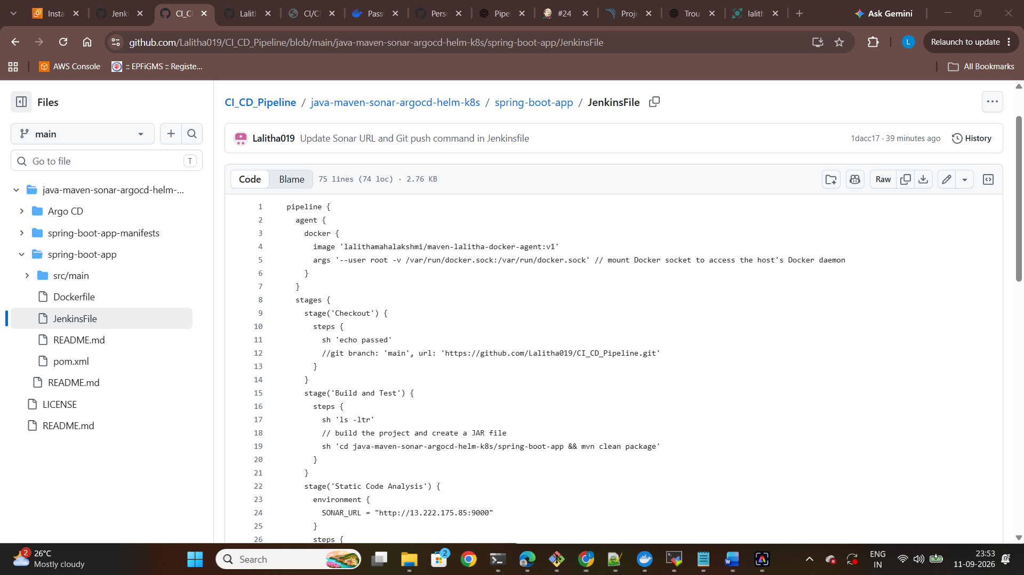
- Jenkins Pipeline Configuration and credentials:
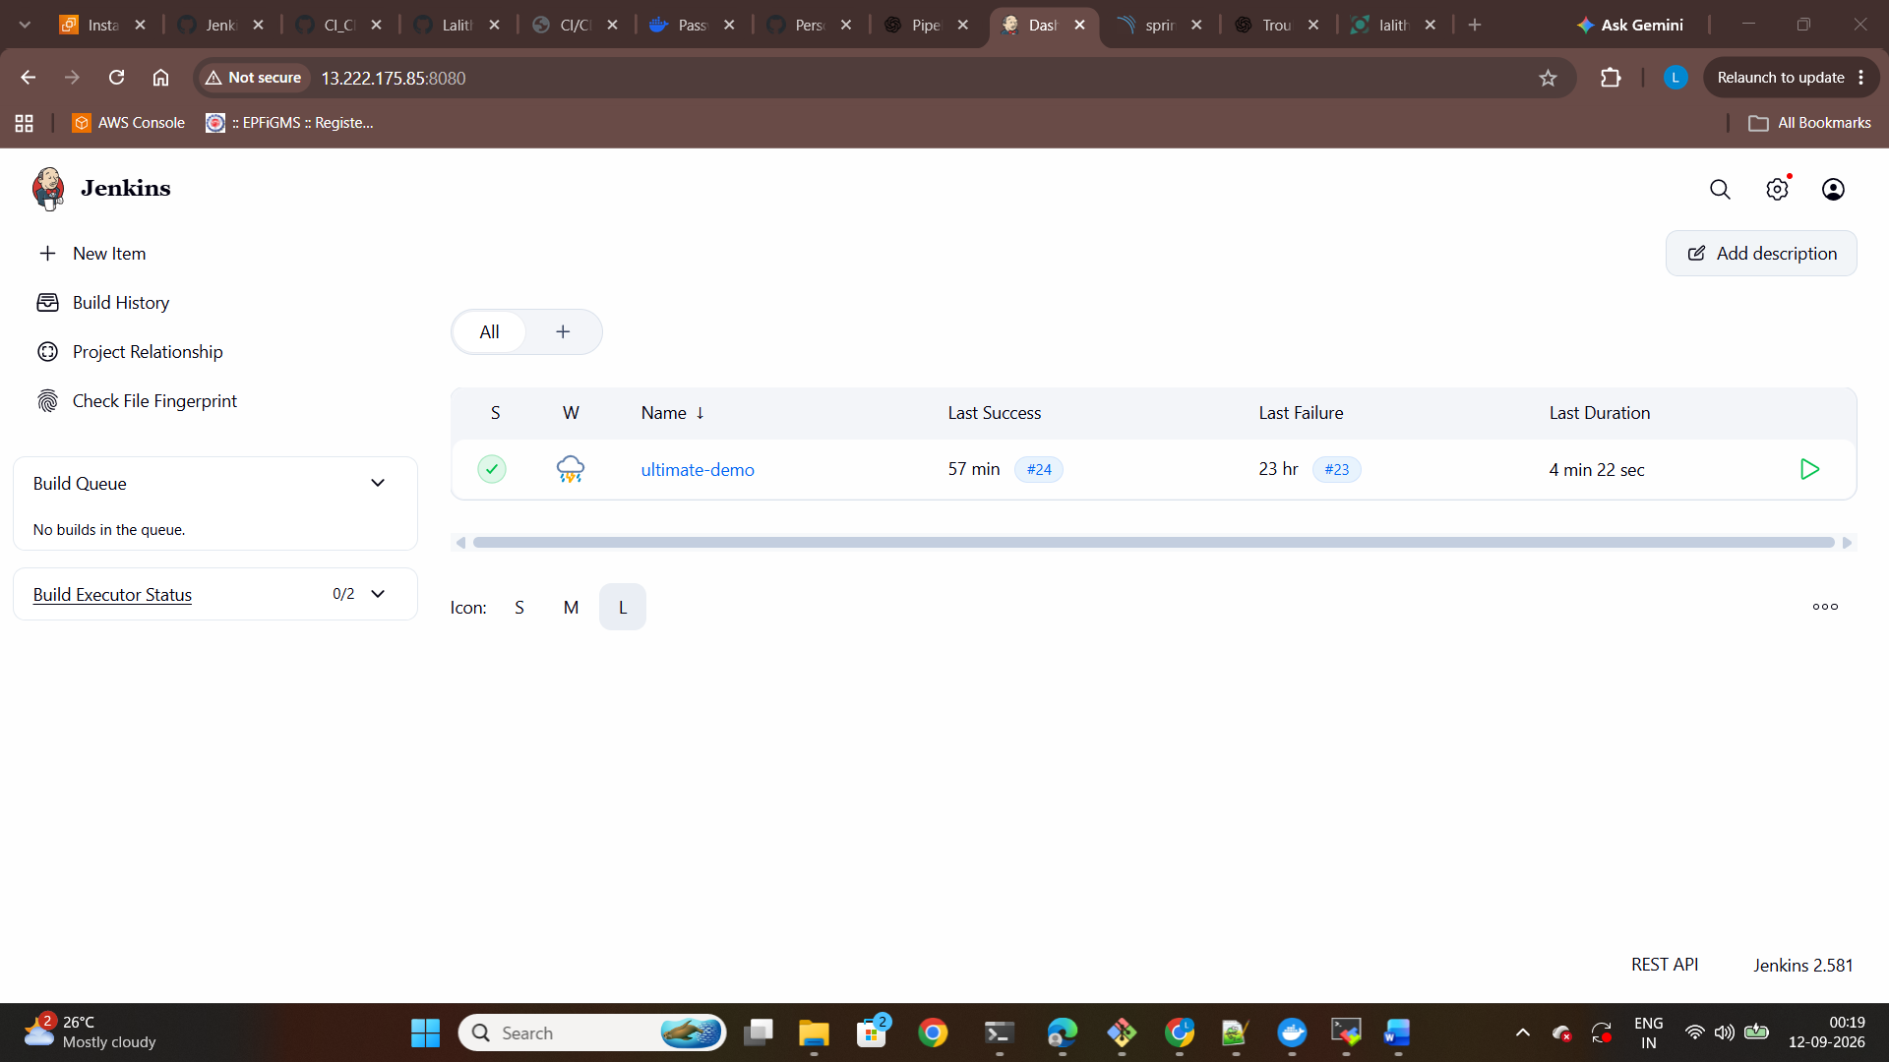
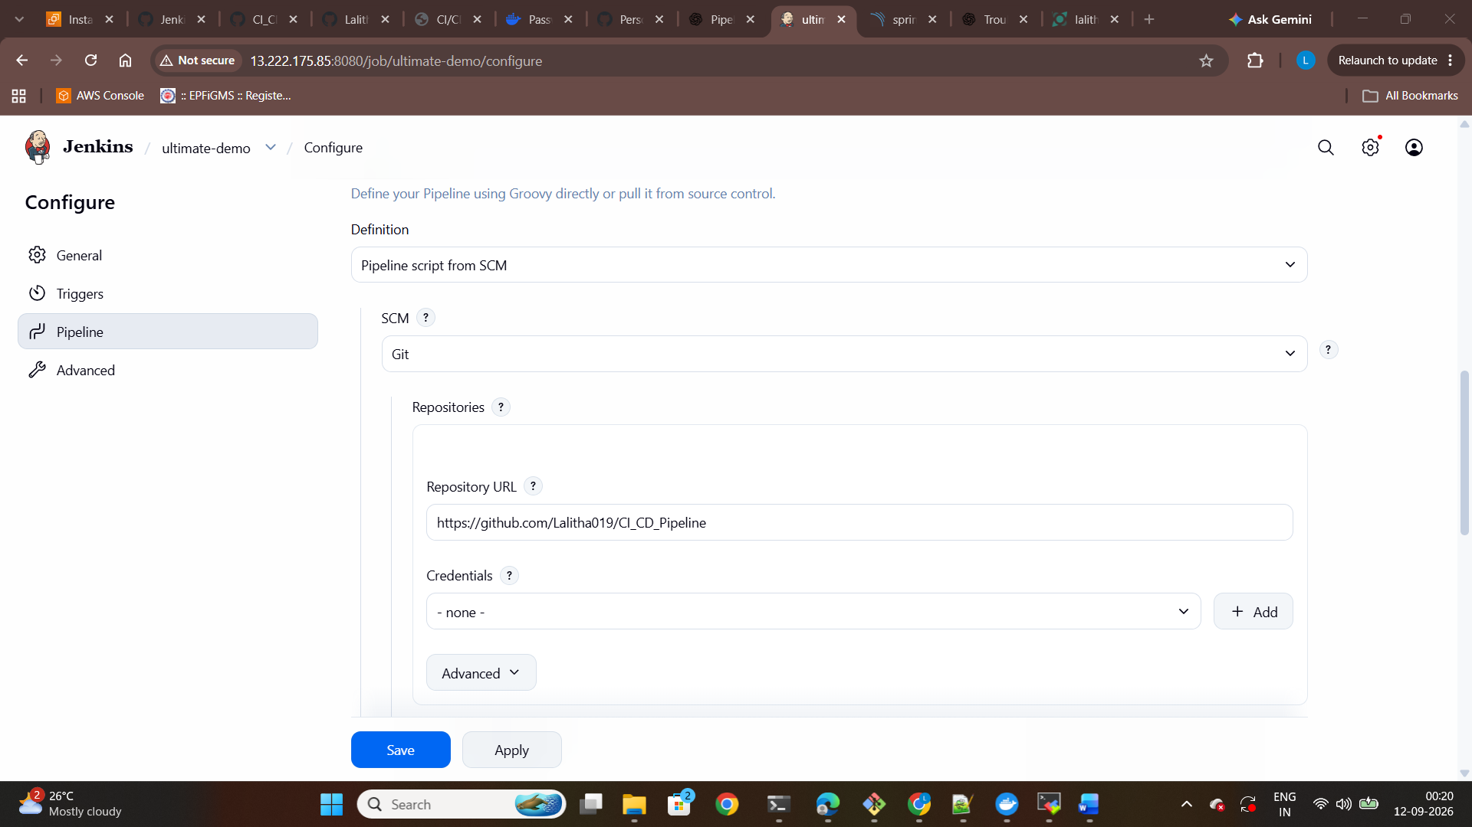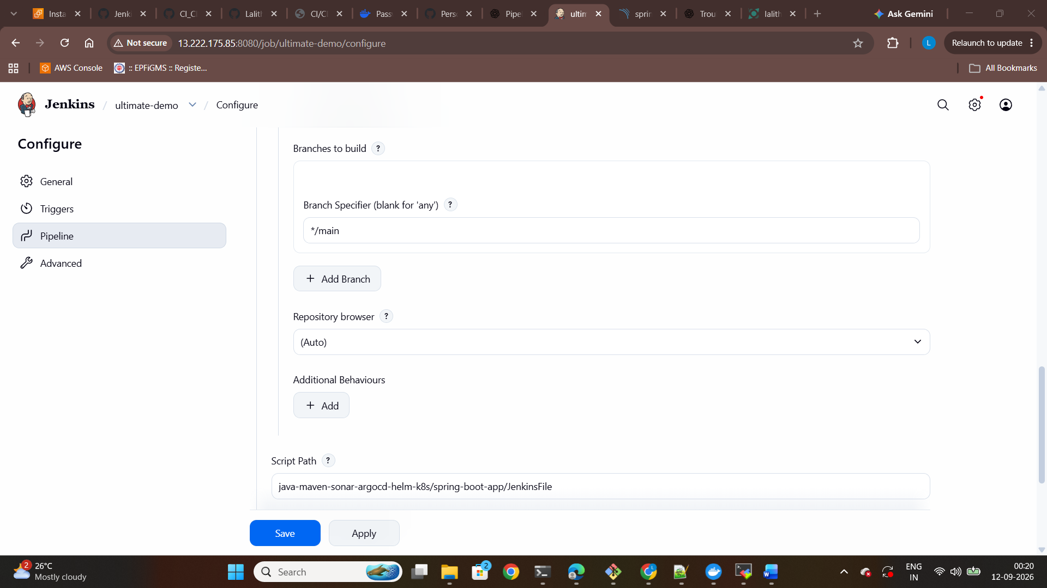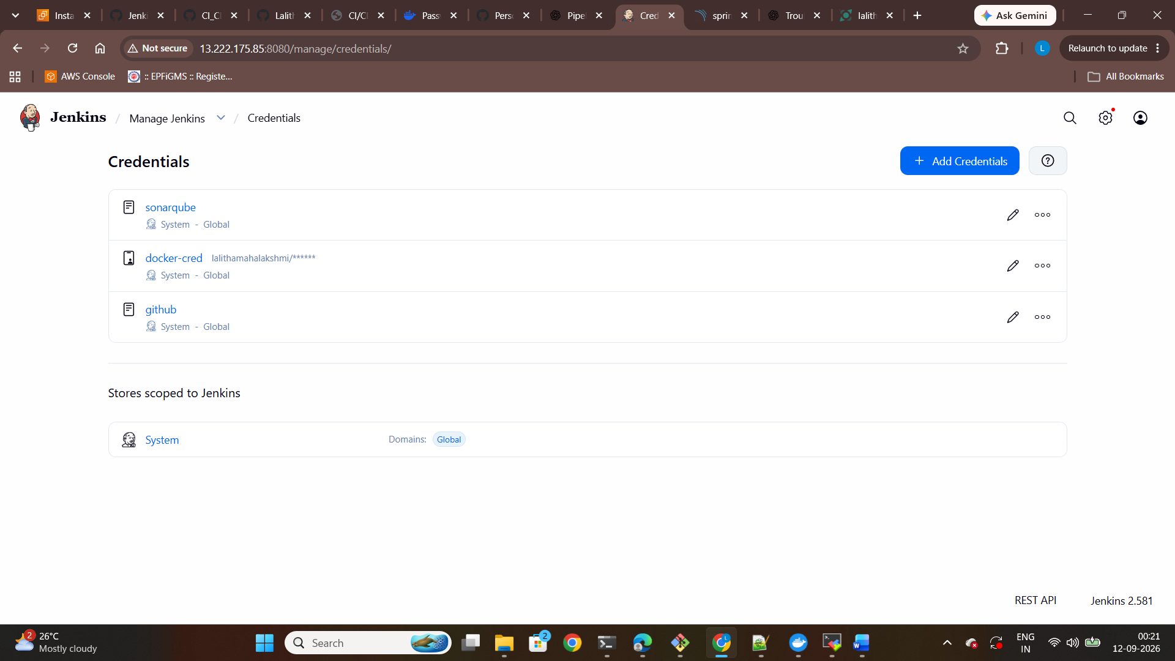
- Successful Jenkins CI/CD Pipeline:
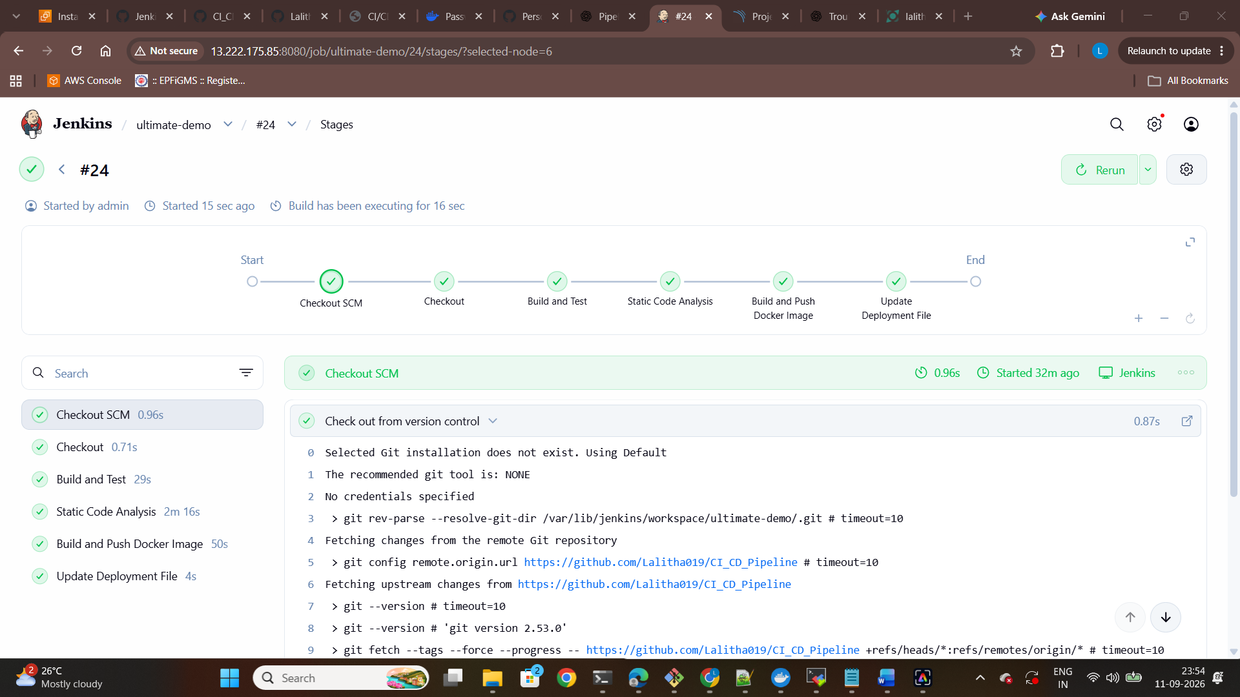

- Maven Build and Test Successful:
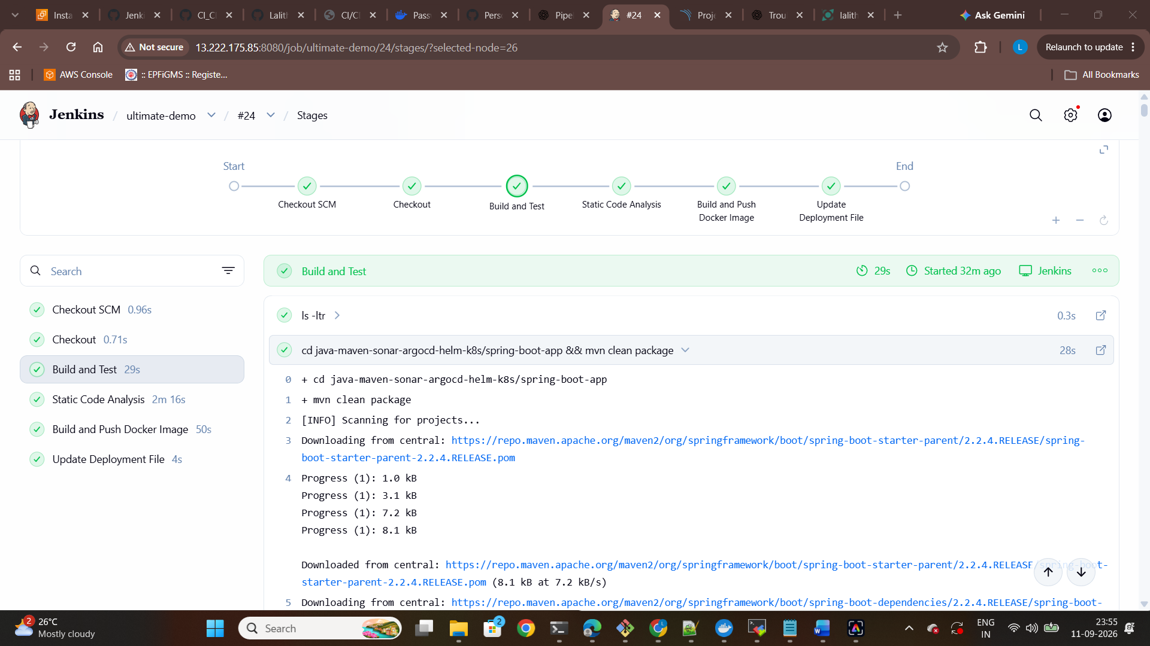
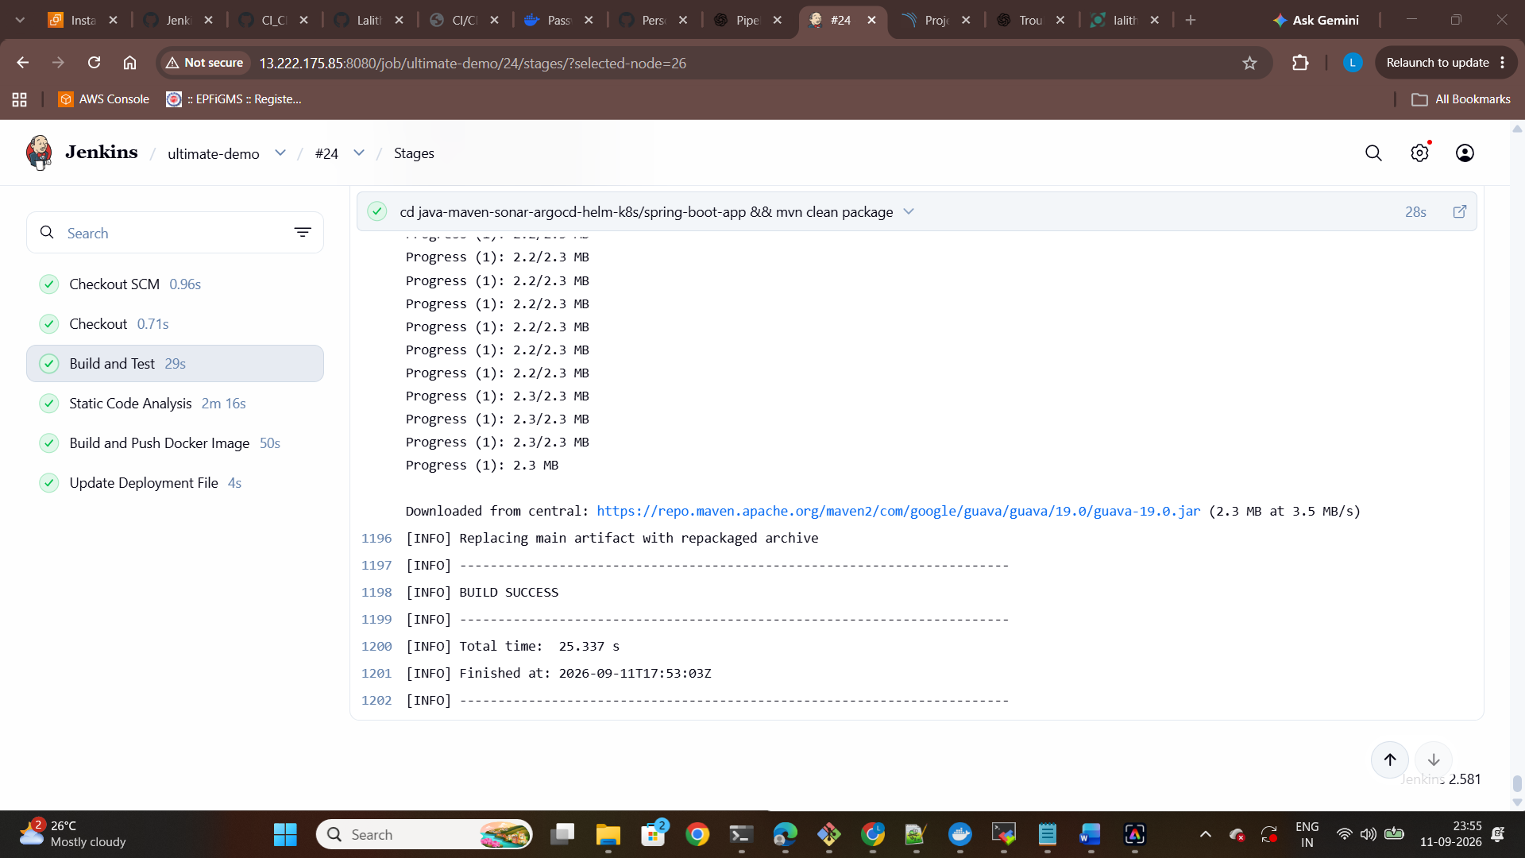

- Static Code Analysis using Sonarqube:
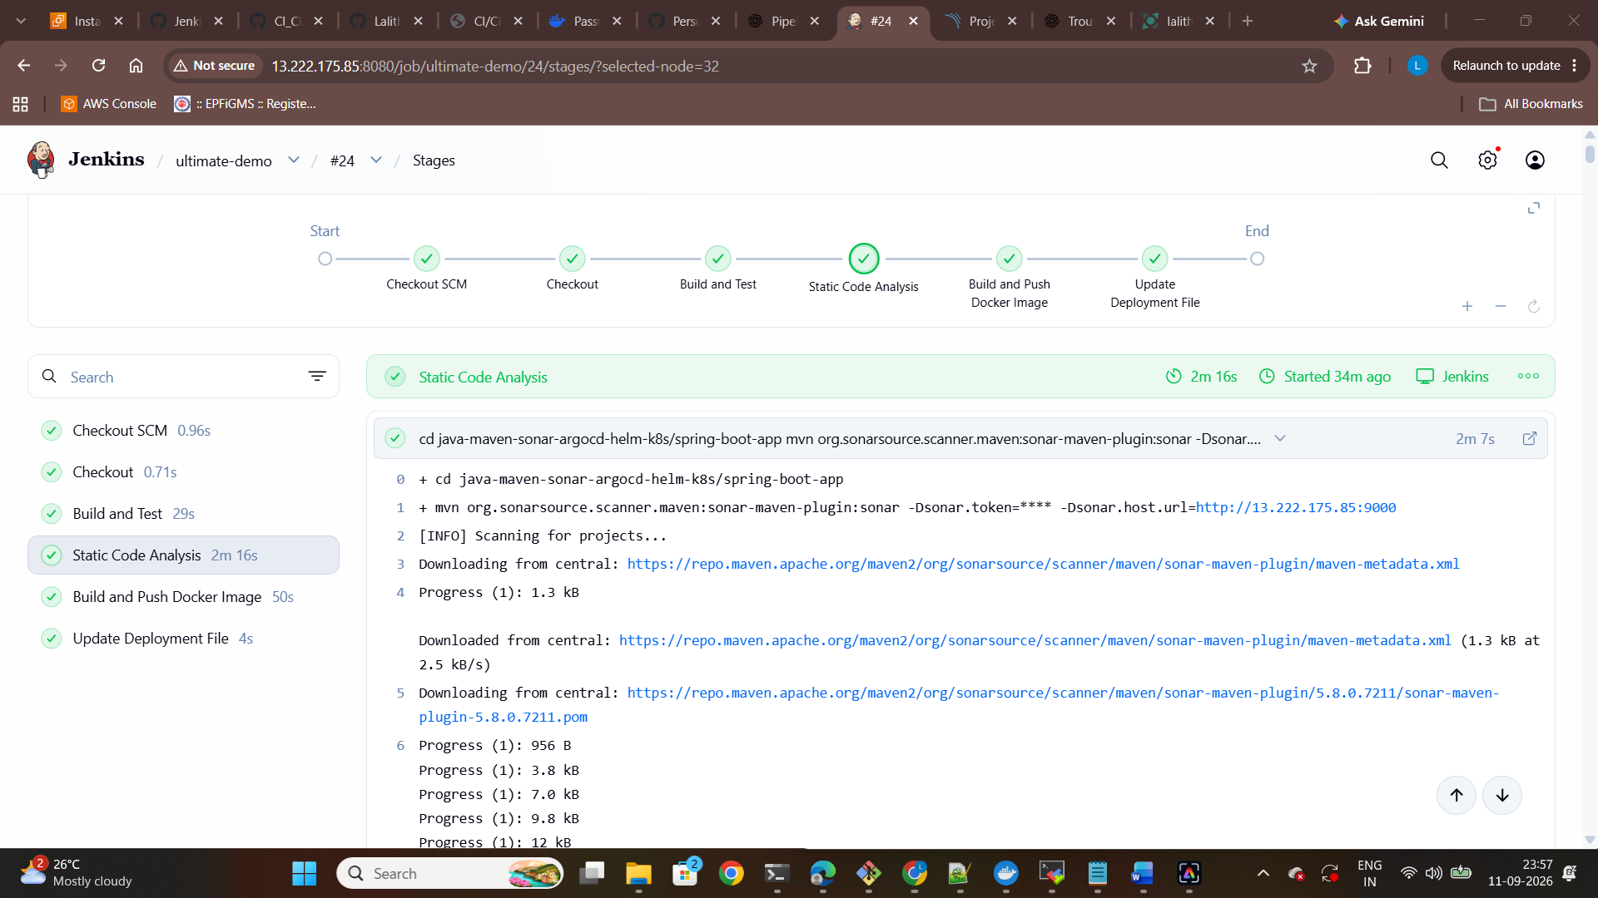
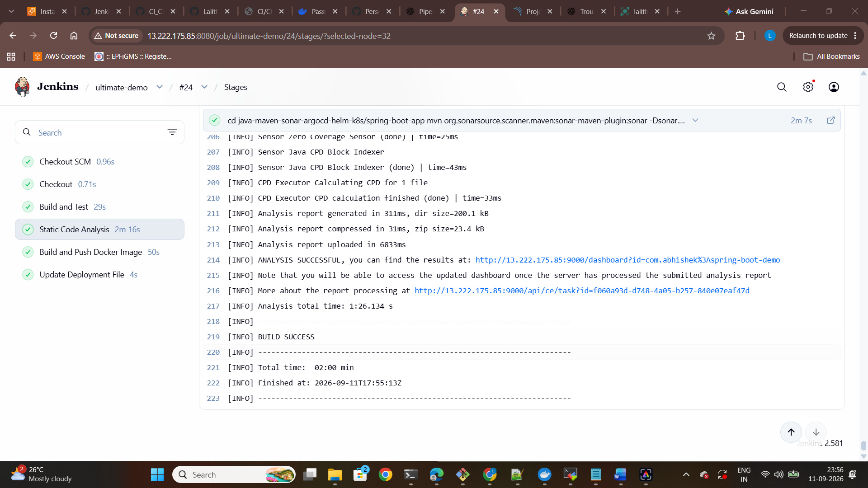

- Sonarqube Analysis Result:
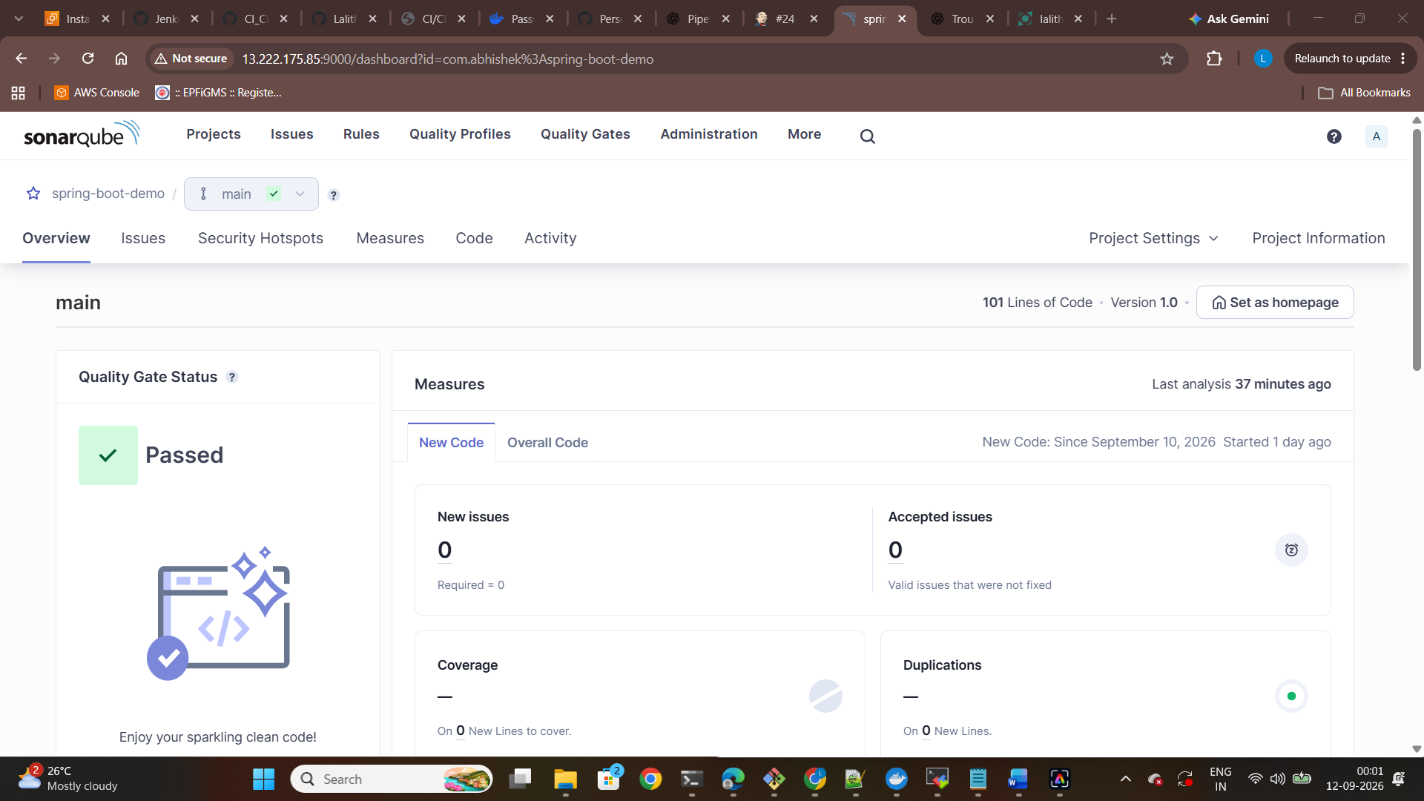
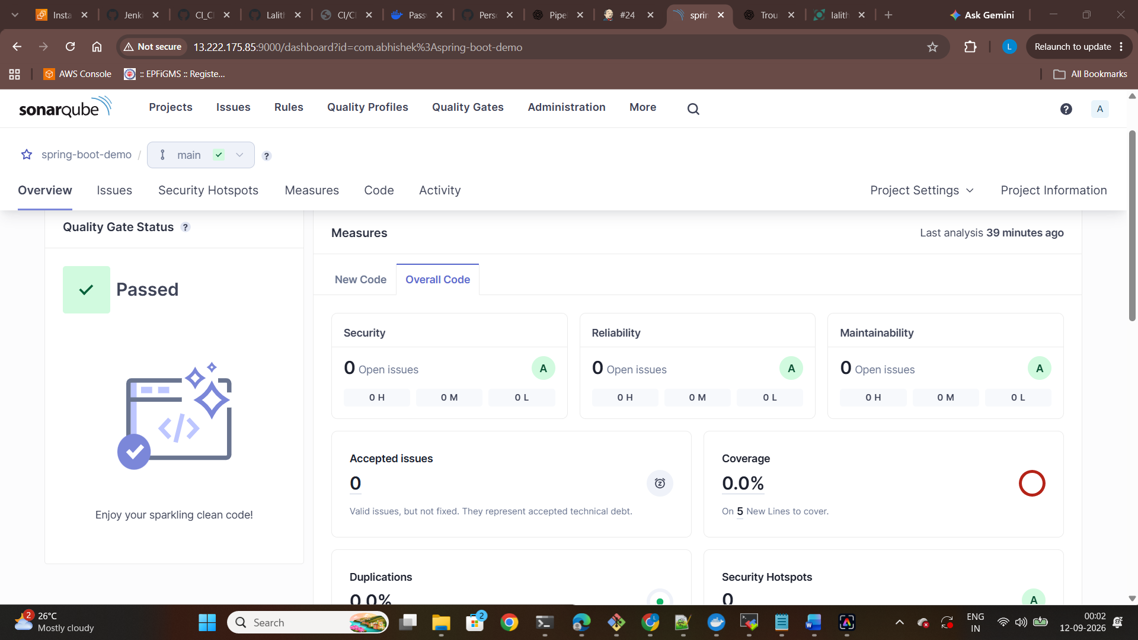
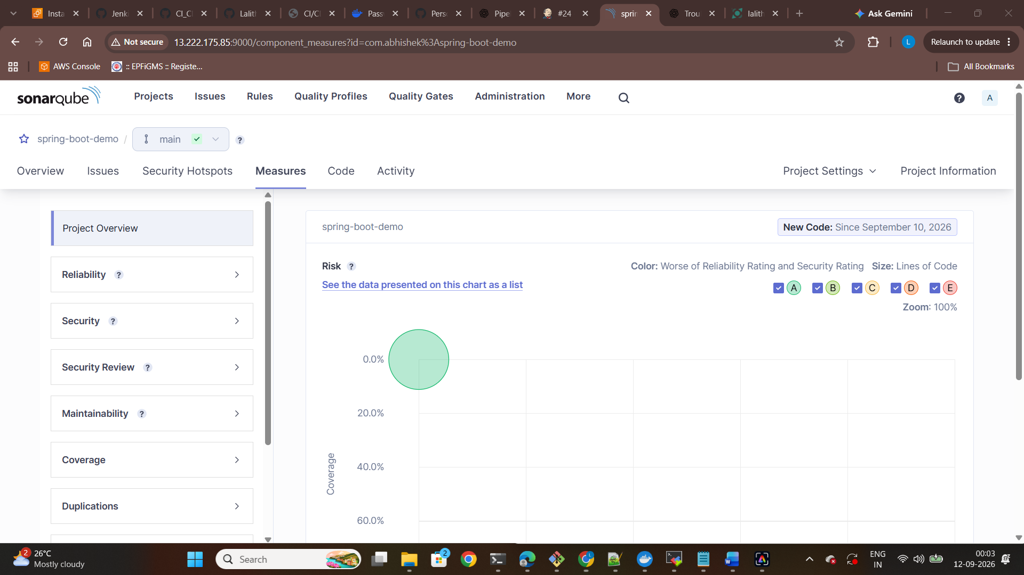

- Docker Image Build:
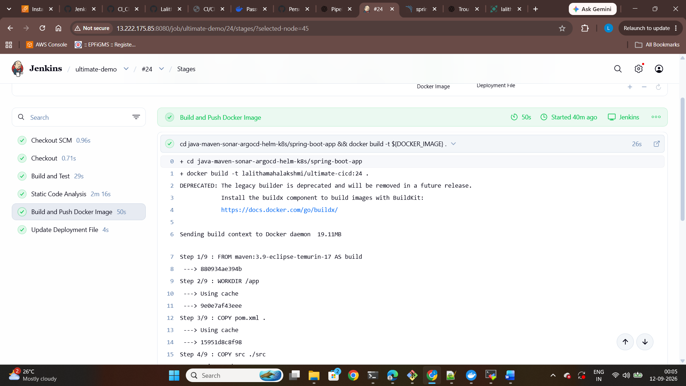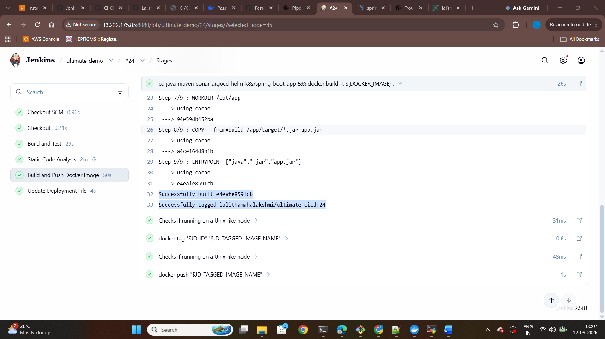

- Docker Image Push to Registry:
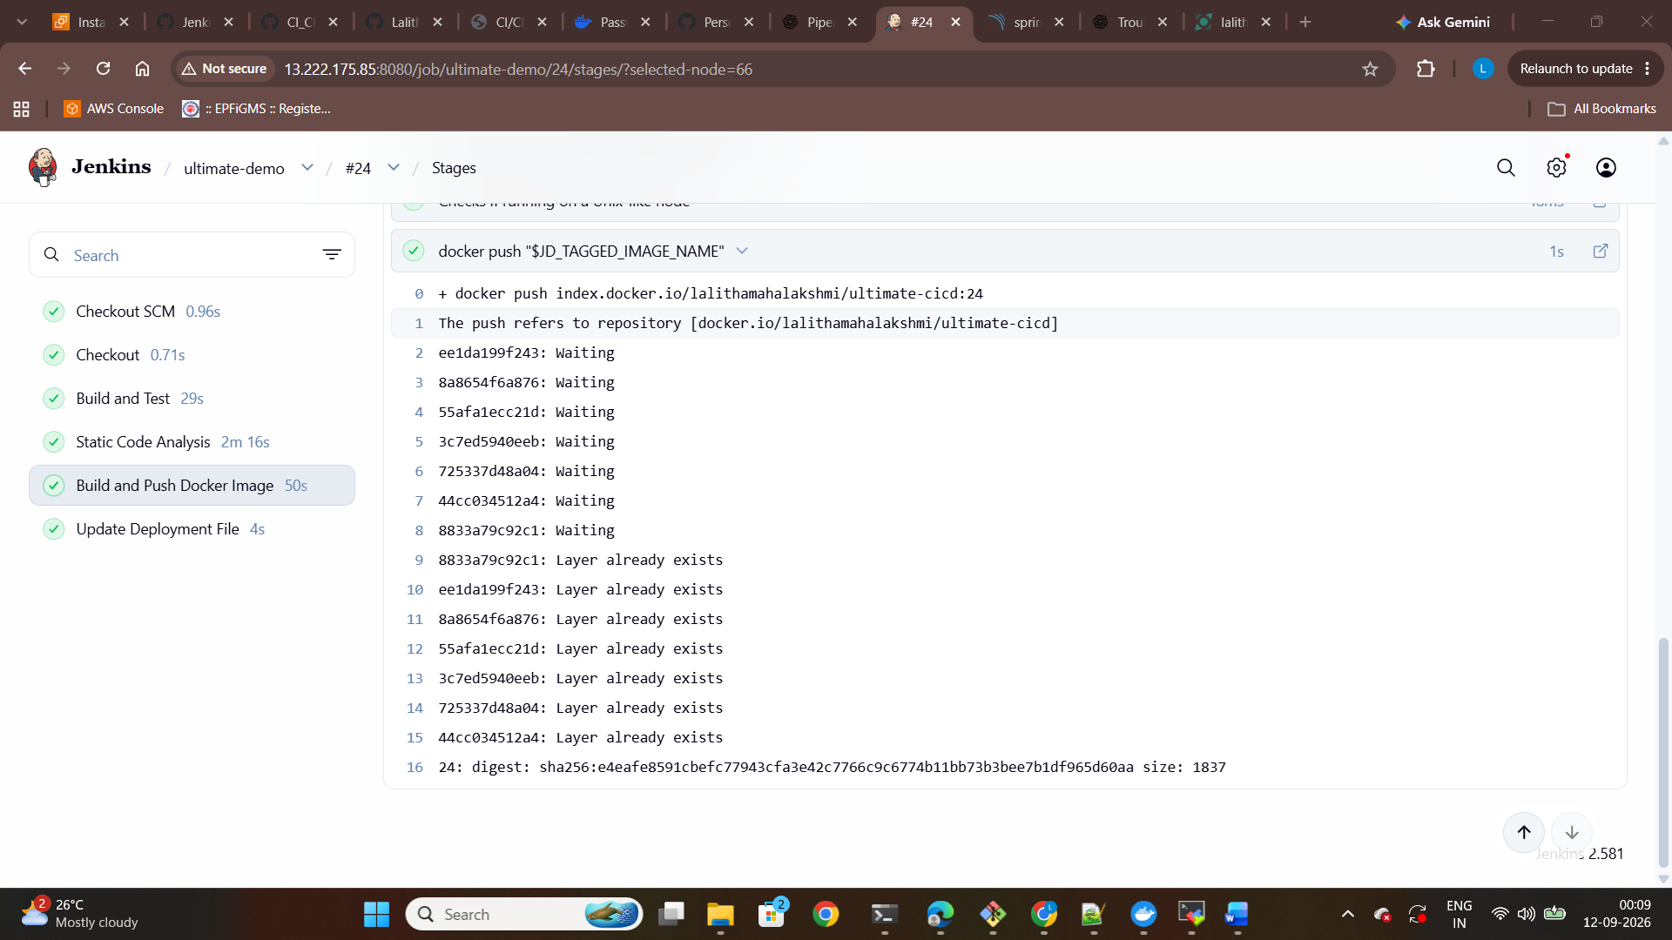
- Deployment Manifest updated with New Image tag:
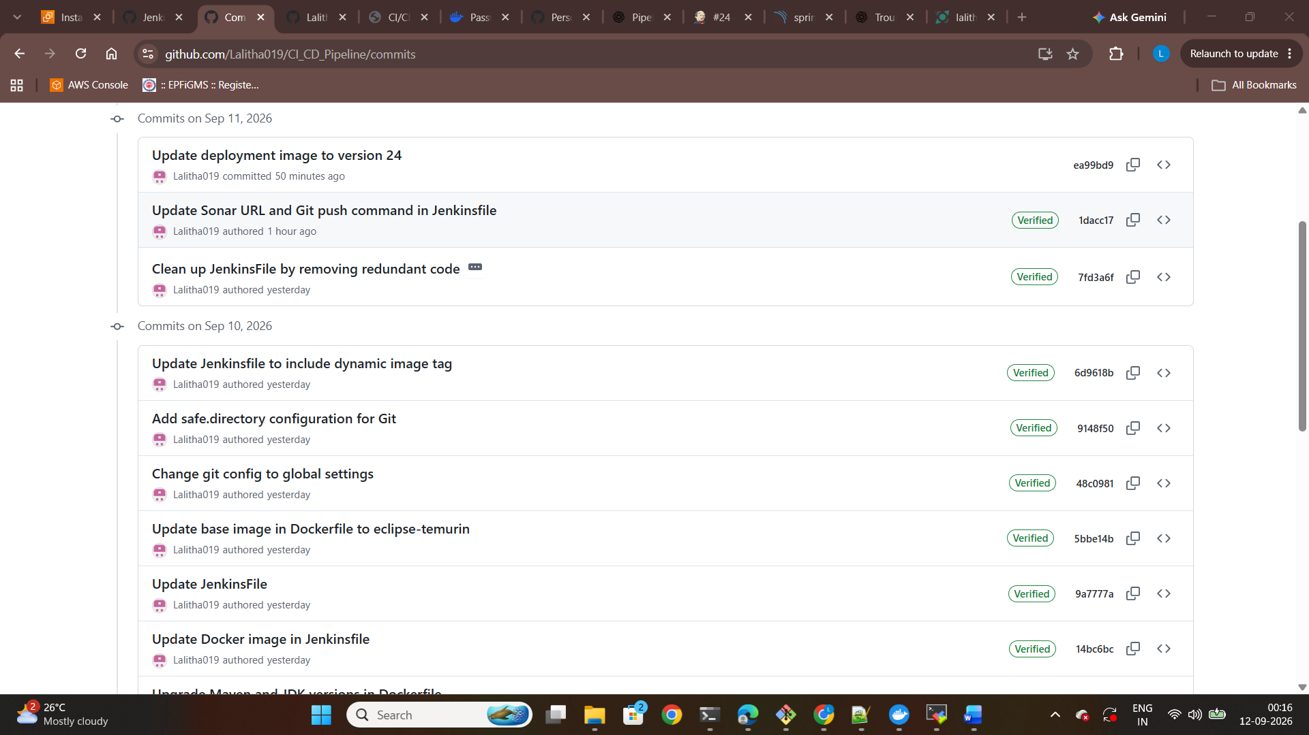

- Automated Github Commit:
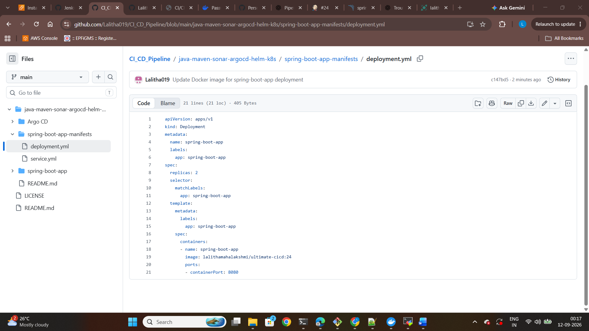
- Troubleshooting:
Problem | Solution
SonarQube failed to start | Configured Java 17
EC2 had low memory | Added 2 GB swap
Elasticsearch startup issue | Increased vm.max_map_count
Jenkins stopped after Java change | Configured Jenkins to use Java 21
Jenkins node went offline | Adjusted disk-space monitoring thresholds
Docker push authorization failed | Logged into Docker Hub
SonarQube authorization failed | Configured Jenkins SonarQube credential
Git dubious ownership | Added Jenkins workspace as safe directory
GitHub credential error | Corrected Jenkins GitHub credential configuration

